American University of Beirut

EECE 310L: Electric Circuits Laboratory
Experiment 4
RC and RLC Circuits

Name: Freddy Vartabedian
ID: 201203799
Email: fkv00@aub.edu.lb
Section: 5
Group: 8
October 28, 2012

Table of Contents Page
- Objectives ……………………………………………………..4
- Lab equipment used ………………………………………… 4
- Lab tools used ……………………………………………. 4
- Components used ………………………………………… 4 Experimental Procedure and Discussion…………………… 5-8
- Phase Shift Measurements…………………………………5
1. Circuit Diagram
2. Experimental Procedure
3. Measurements and Results
4. Discussions …………………………………………. 8
B. Lag and Lead Networks …………………………………8-14
1. Lag Circuit Diagram
2. Experimental Procedure
3. Measurements and Results
1’. Lead Circuit Diagram ………………………………14-20
2’.Experimental Procedure
3’. Measurements and Results
4. Discussions ………………………………………… 20-22
C. Series RLC Circuits …………………………………… 23-30
1. RLC Circuit Diagram
2. Experimental Procedure
3. Calculations, Measurements and Results
4. Discussions……………………………………………… 29
- References……………………………………………………. 31
- Problems and Mistakes

List of Figures, Photos and Tables:
Tables: Page
1. Resistor Measures …………………………………………………………………………….. 4
2. Measurements of phase angle using Y-T method………………………………….... ……….. 7
3. Measurements of phase angle using Lissajous method ………………………………………. 7
4. Calculated results for lag networks……………………………………………………………10
5. Lag network sinusoidal input measurements………………………………………………….10
6. Lag network with square signal measurements……………………………………………… 12
7. Comparison and Percent Error for lag networks……………………………………………. 14
8. Comparison and Percent Error for lag networks……………………………………………. 14
9. Lead network output voltage calculated values……………………………………………… 16
10. Lead network output voltage with sinusoidal input measured……………………………….16
11. Lead network with square wave measured values………………………………………… 19
12. Comparison of lead square and sinusoidal outputs and percent errors……………………... 21
13. Resonant frequency and bandwidth values………………………………………………... 24
14. Experimental results for RLC circuit…………………………………………………... 24
15. Results for RLC 1st table…………………………………………………………………... 24
16. Results for RLC 2nd table…………………………………………………………................ 26
17. Results for RLC 3rd table…………………………………………………………............... 28

List of Figures
- Circuit Diagram…………………………………………………………………………...5
- Lissajous Figure…………………………………………………………………………...6
- Lag circuit………………………………………………………………………….. 8
- Lead Circuit……………………………………………………………………………...14
- RLC Circuit………………………………………………………………………………22
Oscilloscope photos
- Sinusoidal lag network……………………………………………………………….10-11
- Square lag network…………………………………………………………………...12-13
- Sinusoidal lead network………………………………………………………………16-17
- Square lead network………………………………………………………………….18-19
Plots:
Plot of 1st set……………………………………………………………………………………..25
Plot of 2nd set……………………………………………………………………………..............27
Plot of 3rd set……………………………………………………………………………………..29

- Objectives:
- Investigate the frequency response and time response of RC circuits.
- Investigate the frequency response of RLC circuits.
- Use the oscilloscope to do frequency, time and phase measurements.

- Lab Equipment Used:
The main Equipment used:
- Function generator
- Oscilloscope
- Breadboard
- Digital Multimeter
- Lab Tools Used:
We didn’t use any tools from our toolbox. The wires were already prepared.
IV. Components Used:
- Resistors of several values
- Capacitors
- Inductors
- Wires

Table 1:
Resistor Measures
Theoretical Value | Measured Value | % Error
56Ω | 54.36Ω | 2.93
100Ω | 97.85Ω | 2.15
1KΩ | 0.979KΩ | 2.1
20KΩ | 19.86KΩ | 0.7

- Experimental Procedure and Discussion

- Phase Shift Measurements
A1: Circuit Diagram
Figure 1:
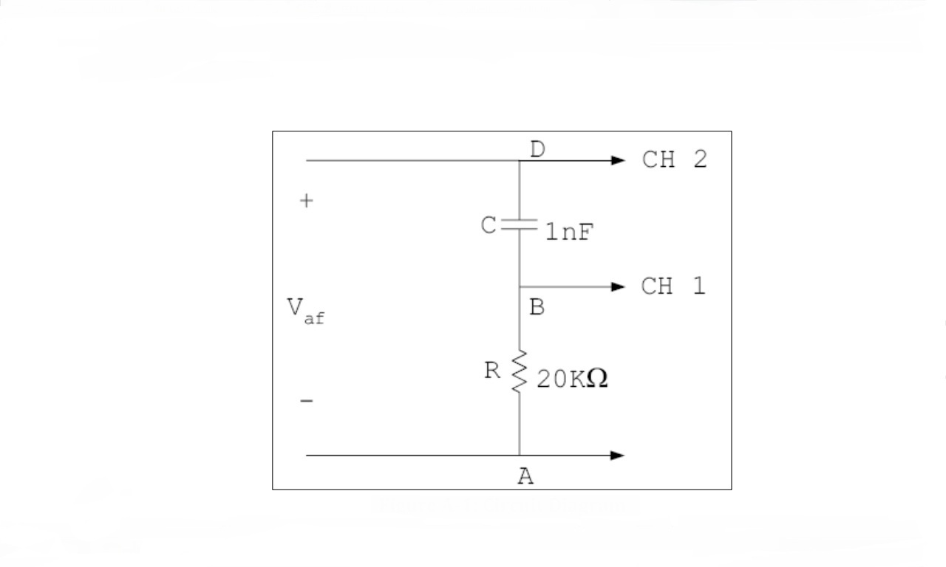
A2.Experimental Procedure:
Using a 20 KΩ resistor and a 1 nF capacitor, we designed the RC circuit on the breadboard. We then applied a sinusoidal voltage V_{af} = 6v peak to peak of frequency 5 KHz to the input of the above circuit. We then applied V_{BA} (voltage across resistor) to CH 1 of the oscilloscope and V_{DA} (or V_{af}) to CH 2.
Assumptions: We assumed wires have no resistance and disregarded the 0.7% error of the 20KΩ resistor used.
A2. 1: Time Shift Method:
This method exploits the fact that a phase difference is equivalent to a time shift, meaning that the phase difference between 2 sinusoidal waves is equal to a shift in the time domain. After setting the oscilloscope to the Y-T mode and superposing the two traces of V_{BA} and V_{DA} to have the same horizontal axis,( and adjusting the VOLT/DIV and SEC/DIV settings to get stable traces), we measured the phase difference ϕ on the oscilloscope by measuring the time difference between the two signals, ΔT. Since each period T corresponds to an angle of 360º,
ϕ=$\frac{ΔTx360}{T}$ Where ϕ is the phase difference in degrees, ΔT is the time difference and T is the period of the sine signal.
A2.2: The Lissajous Method:
In this method leaving the connections as before, we use the X-Y mode on the oscilloscope, and V_{BA} and V_{DA} are connected to the X and Y channels. An ellipse called the Lissajous figure is observed on the screen as a result of the superposition of two perpendicular sinusoidal signals V_{BA} and V_{DA}. However, the ellipse has to be centered symmetrically using the horizontal and vertical position knobs. The following figure is obtained:
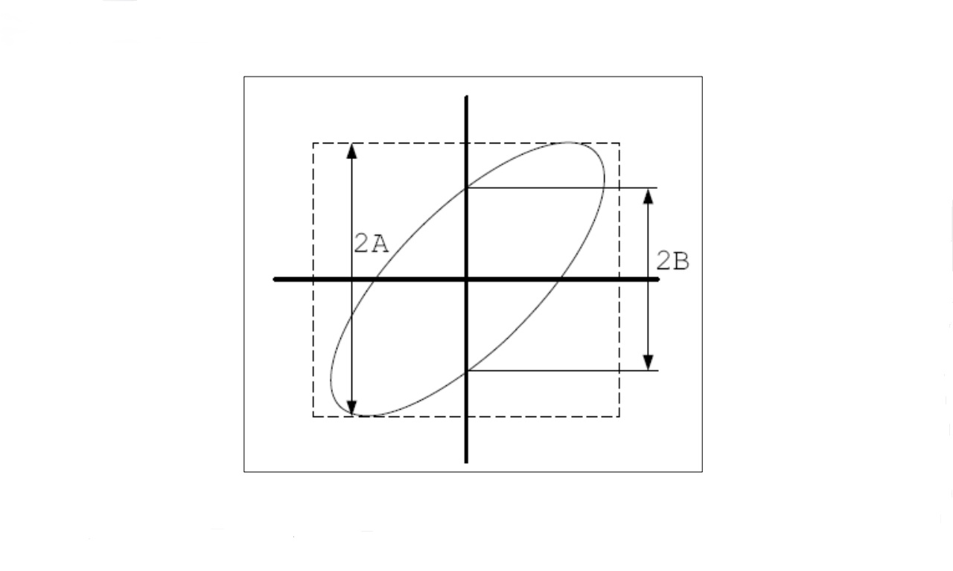Figure 2
The phase difference can be calculated from the figure using the formula:
Φ=sin⁻¹ ($\frac{B}{A}$)

A3. Measurements and Results for A2.1 and A2.2:
Theoretical measure:
Formula used: tanϕ=$\frac{Xc}{R}$
X_{c=}$\frac{1}{wC}$₌$\frac{1}{2лfC}$
f=5 KHz, C=1nF and R=20KΩ
X_{c} = 1/2л *(5*10³)*(1*10⁻⁹) = 31830.99
Tanϕ=$\frac{31830.99}{20 ×1000}$ = 1.5915
Φ=57.86º

Experimental results:
Table2
Y-T Format Δ | ΔT=0.000032 sec | T=0.0002 sec | Φ=57.6 degrees

Calculation: ϕ= (0.000032) (360)/0.002 = 57.6º
Table3
Lissajous Figure | 2B=5 | 2A=6.4 | Φ=51.37 degrees

Calculation: sin ϕ=B/A=5/6.4=0.78125
Φ=51.37 degrees
Comparison and errors:
Theoretical value of ϕ= 57.86
Value of ϕ by Y-T method: 57.6 and %error= (57.86-57.6)(100)/57.86=0.45%
Value of ϕ by Lissajous method: 51.37 and % error = 57.86-51.37) (100)/57.86 = 11.22%
Obviously the Y-T method is closest to the theoretical value. The rather high value of error using the Lissajous method may be due to a faulty centering of the ellipse or a misreading of measures on the screen.

A4. Discussions:
The following were observed in the shape of the ellipse while changing the frequency:
- The Lissajous figure turned into a circle at very low frequencies. When A=B the phase difference is 90 degrees (tanϕ=1/2лfC) which is the case for a circle.
- At high frequencies the ellipse turned into a straight line. This is logical since at high frequencies the capacitor acts as a short circuit and V_{out}=RI and phase difference is zero since the only circuit component that is active is the resistor.

- Lead and Lag Networks

B1. Lag Circuits Diagram
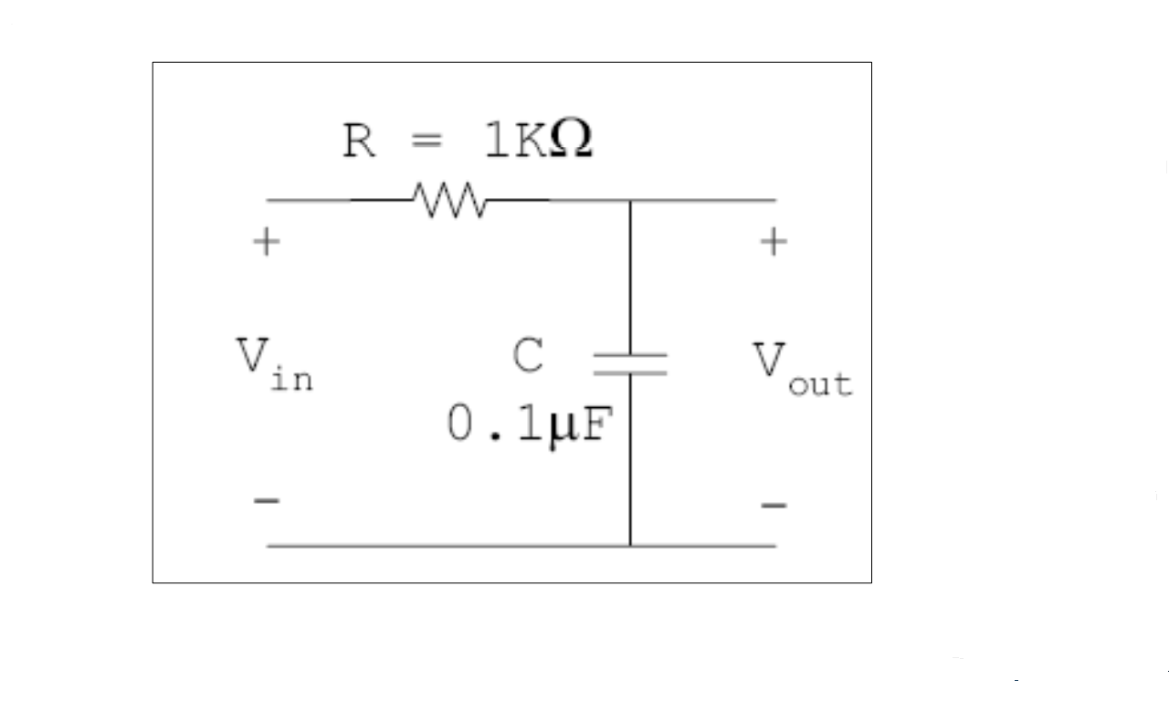Figure 3

B2. Experimental Procedure:
For the lag RC circuit above, we used a1KΩ resistor and a 0.1 μF capacitor. We first supplied a 1V sinusoidal input voltage to the circuit with a frequency of 100Hz and observed the input and output waveforms on the oscilloscope. We than repeated the procedure using frequencies of 1KHz and 10KHz and observed the changes. One channel of the oscilloscope was connected to the input and the other to the output which is across the capacitor.
The whole procedure was repeated using a square wave input instead of a sinusoidal one.
Assumptions: We assumed wires have no resistance and disregarded the 2.1% error of the 1KΩ resistor used.

B3.Measurements and Results:
Theoretical Measures:
For the lag circuit above:
$\frac{Vout(jw)}{Vin(jw)}$=$\frac{1/jwC}{R+1/jwC}$ =$\frac{1}{1+jwC}$
This is a low pass response. As f increases, w increases, and X_{c} tends to zero and C acts as a short circuit and │V_{C(jw)} │tends to zero. High frequencies are attenuated and low frequencies are transmitted with little attenuation.

The magnitude of the transfer function is:$│H\left(jw\right)│=$ $\frac{1}{\sqrt{1+w^{2} C^{2 }R^{2}}}$
And │V_{out peak to peak} =│Vin│*($\frac{1}{\sqrt{1+w^{2} C^{2 }R^{2}}}$)
Note: At high frequencies the magnitude of the output tends to decrease whereas, as the frequency decreases the peak to peak value of the signal increases.
Sample Calculation:
V_{in}=1V, R=1KΩ, C=0.1μF and f=100Hz
V_{out}=1 x 1/√ (2л*100)²(0.1*10⁻⁶)²(1*10³)²= 998mV

Lag Network: Calculated Results (for both sinusoidal and square waves)
Table4
Frequency | Input Voltage | Output Voltage V_{pk-pk}
100Hz | 1 V_{pk-pk} | 998 mV_{pk-pk}
1KHz | 1 V_{pk-pk} | 846 mV_{pk-pk}
10KHz | 1 V_{pk-pk} | - _{pk-pk}

- Lag Network Sinusoidal Input Measured:
Table5
Frequency | Input Voltage | Output Voltage V_{pk-pk}
100Hz | 1 V_{pk-pk} | 1060 mV_{pk-pk}
1KHz | 1 V_{pk-pk} | 860 mV_{pk-pk}
10KHz | 1 V_{pk-pk} | 166 mV_{pk-pk}

Oscilloscope Figures for Sinusoidal Lag Network:
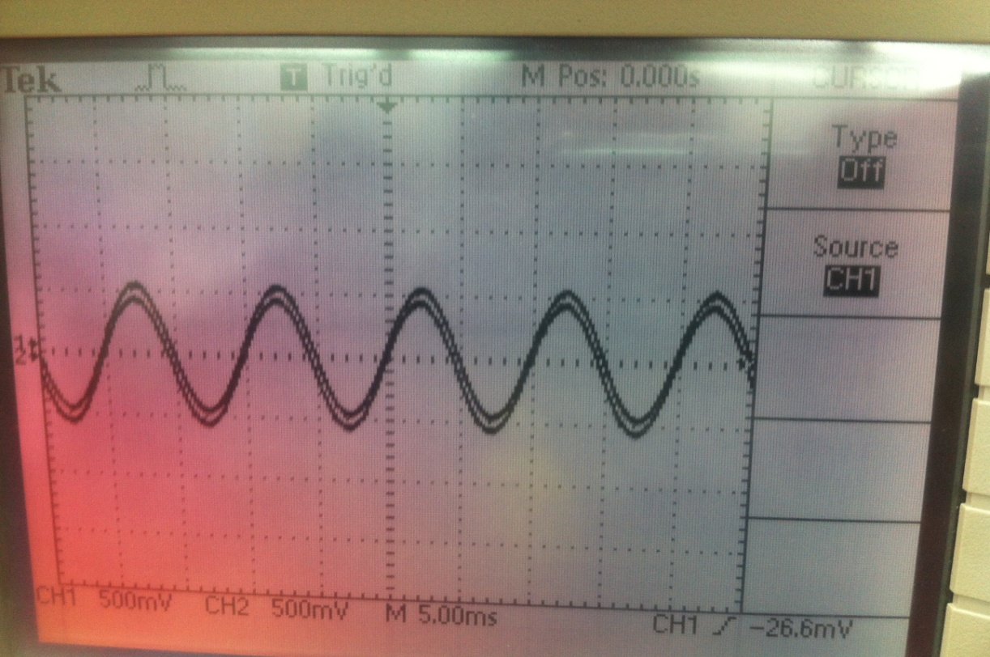f=100Hz

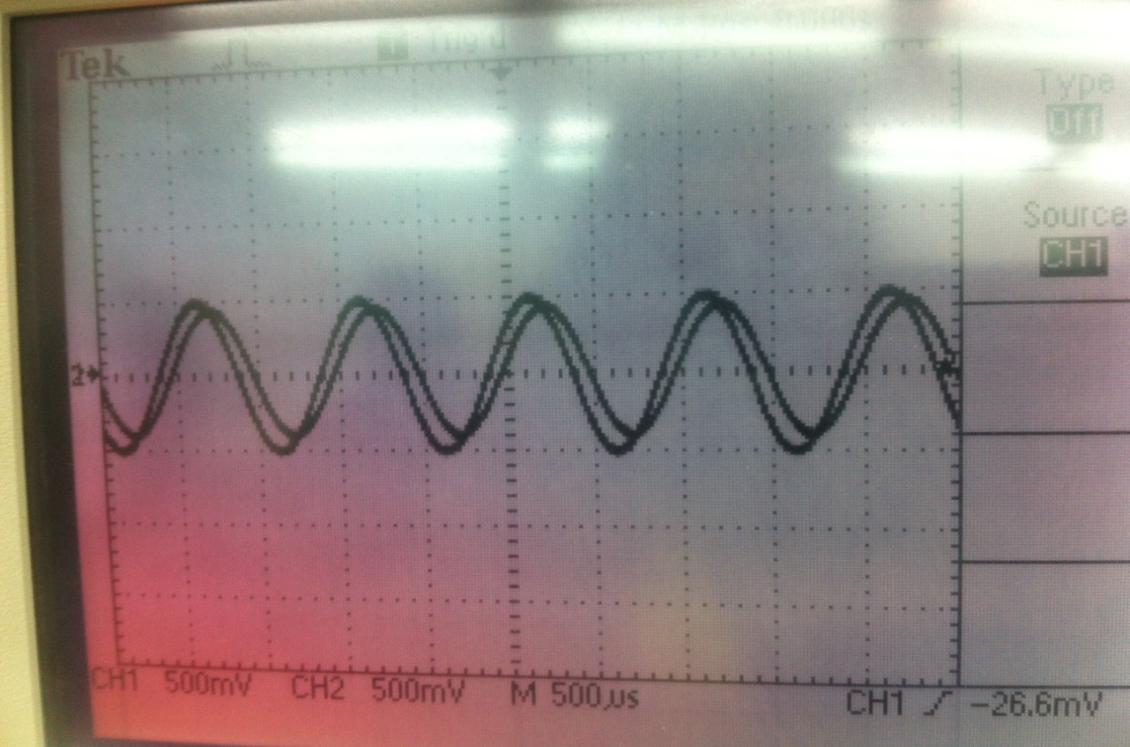f=1KHz

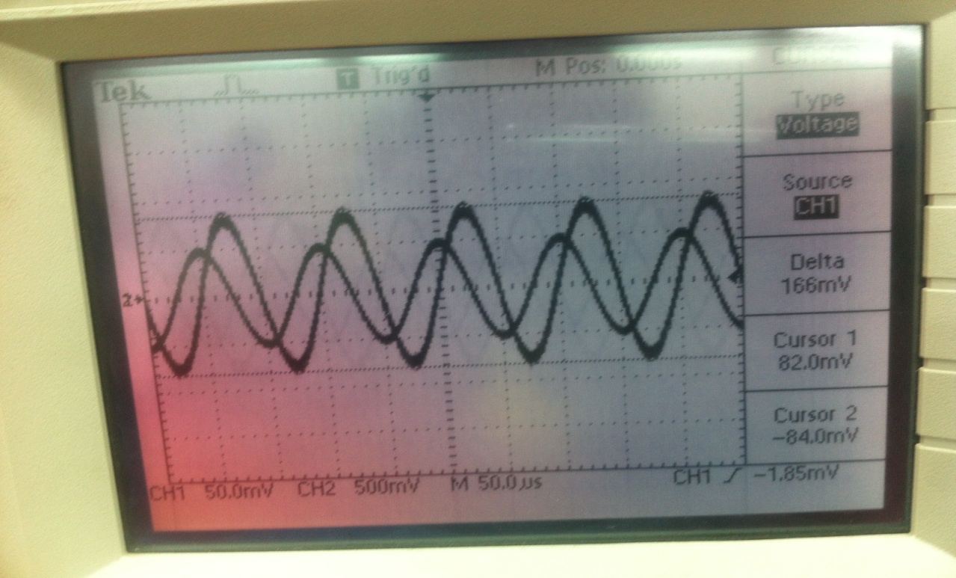f=10KHz

2. Lag Network with Square Wave:
The calculated values of V_{out} for the square wave are the same as those for the sinusoidal wave because the transfer function for the circuit is independent of the nature of the signal and varies with frequency.
Lag Network with Square Wave Measured Results:
Table6
Frequency | Input Voltage | Output Voltage V_{pk-pk}
100Hz | 1 V_{pk-pk} | 1060 mV_{pk-pk}
1KHz | 1 V_{pk-pk} | 2040 mV_{pk-pk}
10KHz | 1 V_{pk-pk} | 520 mV_{pk-pk}

Oscilloscope Figures for lag square signal:

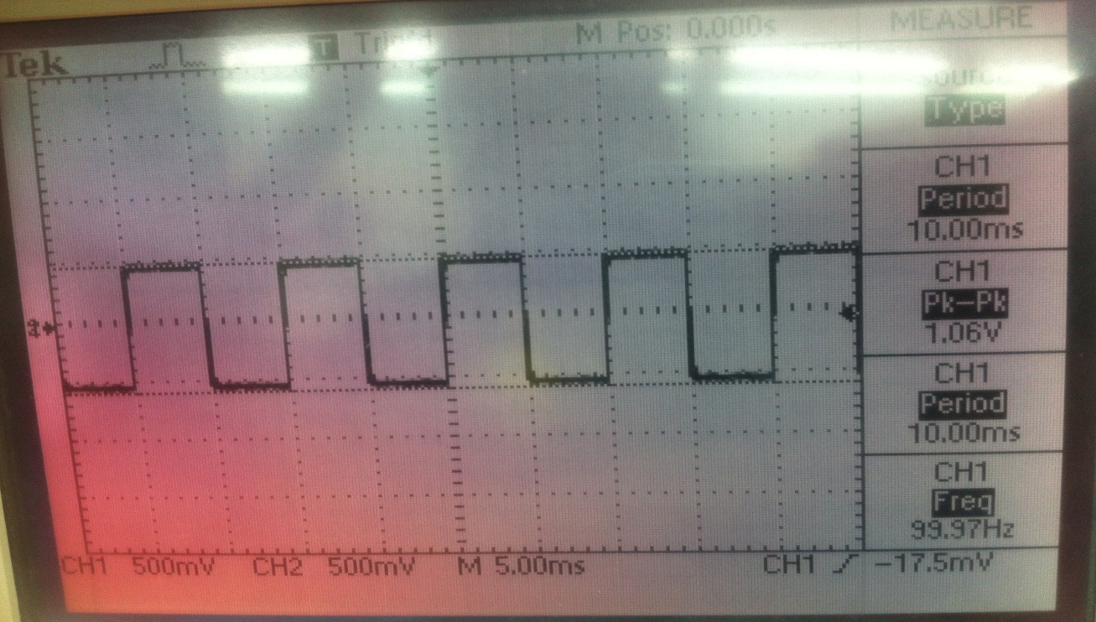f=100Hz

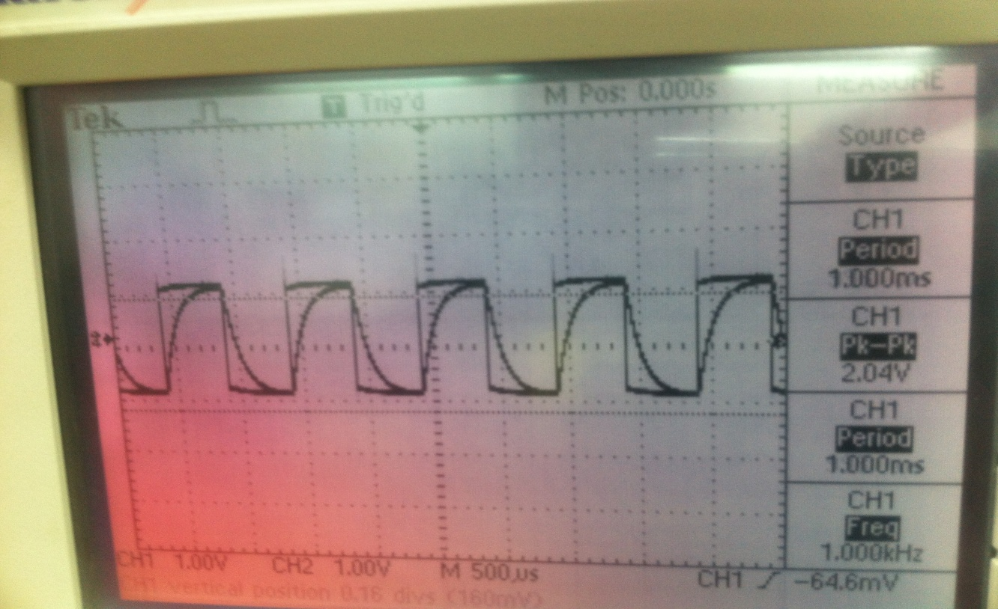
f=1 KHz
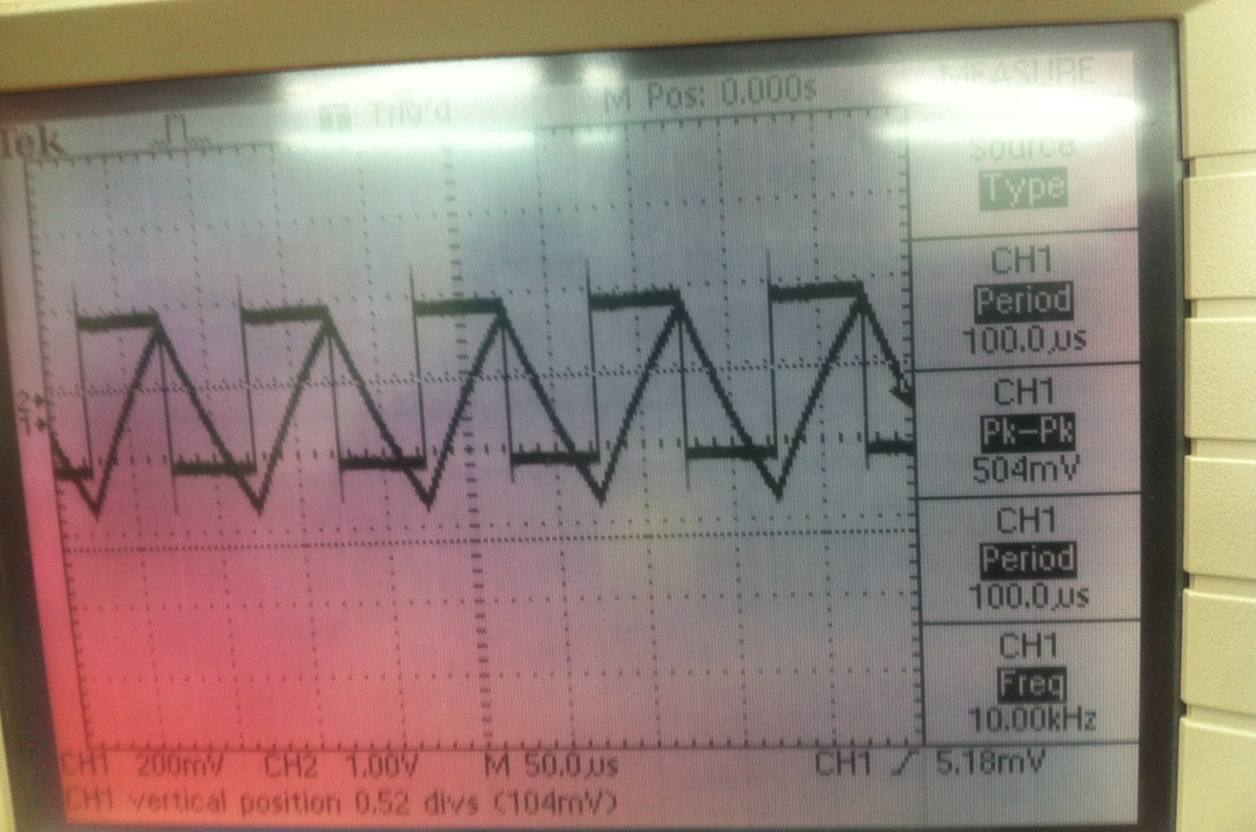
f=10KHz

3. Comparison and Percent Error:
Table7
Frequency | V_{out} Theoretical | V_{out} for sinusoidal input | V_{out} for square signal input
100Hz | 998 mV | 1060mV | 1060mV
1KHz | 846 mV | 860mV | 2040mV
10KKz | 157 mV | 166mV | 520mV

Table8
Frequency | %Error for Sinusoidal input | %Error for Square input
100KHz | 6.2% | 6.2%
1KHz | 1.65% | 141%
10KHz | 5.7% | 231.2%

The values measured for the sine wave input are closest to the theoretical values.

Lead Network:
B1’. Lead Network Circuit Diagram:
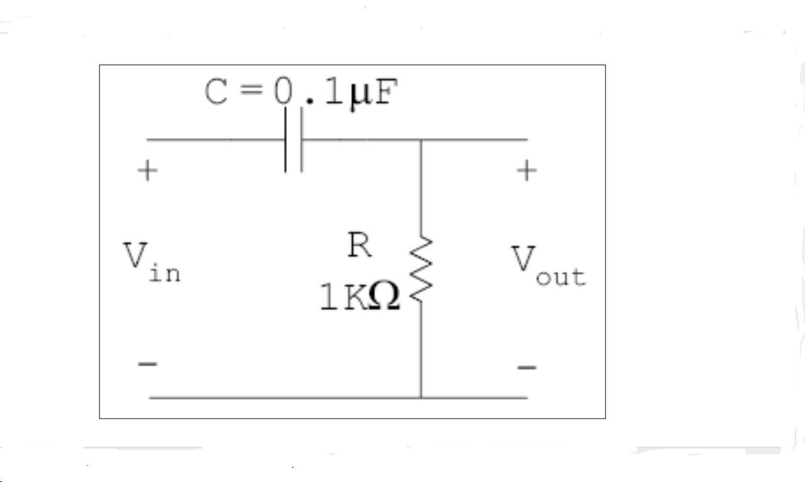Figure 4

B2’. Experimental Procedure:
For the lead RC circuit above, we used a1KΩ resistor and a 0.1 μF capacitor. We first supplied a 1V sinusoidal input voltage to the circuit with a frequency of 100Hz and observed the input and output waveforms on the oscilloscope. We than repeated the procedure using frequencies of 1 KHz and 10 KHz and observed the changes. One channel of the oscilloscope was connected to the input and the other to the output which is across the resistor.
The whole procedure was repeated after using a square wave input instead of a sinusoidal one.

B3’. Measurements, Calculations and Results:
H _{(jw) =}$\frac{R}{R+1/jwC}$ ₌ $\frac{jwRC}{1+jwRC}$
This is a high pass response. As f increases, V_{R(jw)} increases and X_{c} tends to zero, and │V_{R(jw)} │ tends to one as C acts as a short circuit. Low frequencies are attenuated, whereas high frequencies are transmitted with little attenuation.
│V_{out}│/│V_{in}│= │H (jw) │= $\frac{wRC}{\sqrt{1+{(wRC)}^{2}}}$

V_{out peak to peak} = V_{in} x ($\frac{wRC}{\sqrt{1+{(wRC)}^{2}}})$

Sample Calculation for V_{out} Theoretical in Lead Network:
Vin =1V, C =0.1μF, R =1KΩ and f=100Hz
Vout = 1*(2л*100)*(0.1*10⁻⁶) / √1+(2л*100)²(0.1*10⁻⁶)²(1*10³)² = 62.7mV

Lead Network Output Voltage Calculated Values:
Table9
Frequency | Input Voltage | Output Voltage V_{pk-pk}
100Hz | 1V_{pk-pk} | 62.7m V_{pk-pk}
1KHz | 1V_{pk-pk} | 532mV_{pk-pk}
10KHz | 1V_{pk-pk} | 987.5mV_{pk-pk}

- Lead Network Output Voltage with Sinusoidal Input Measured:
Table10
Frequency | Input Voltage | Output Voltage V_{pk-pk}
100Hz | 1V_{pk-pk} | 75 mV_{pk-pk}
1KHz | 1V_{pk-pk} | 528m V_{pk-pk}
10KHz | 1V_{pk-pk} | 1020m V_{pk-pk}

Oscilloscope Figures (Lead Sinusoidal Wave):

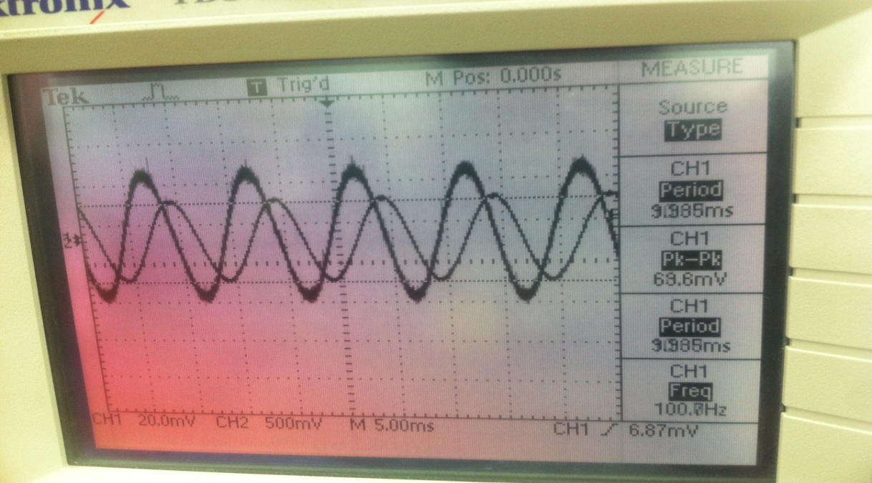f=100Hz
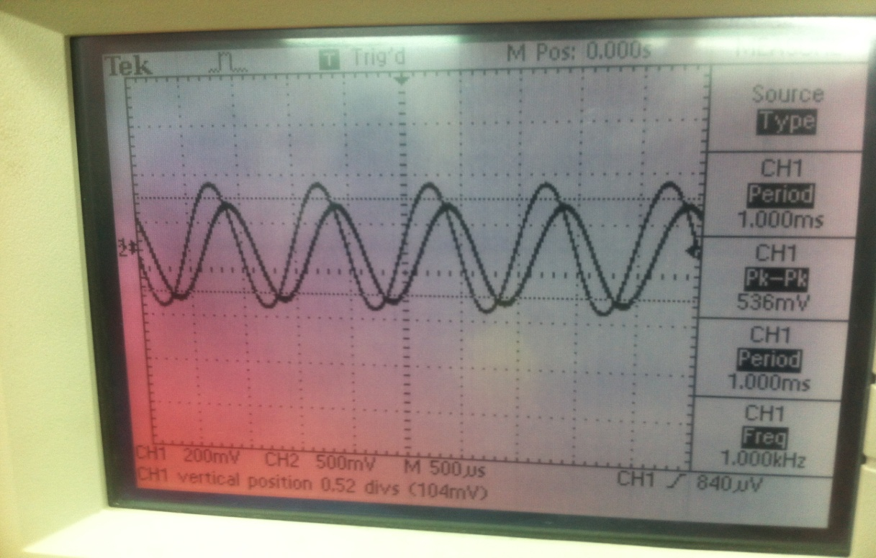f=1KHz

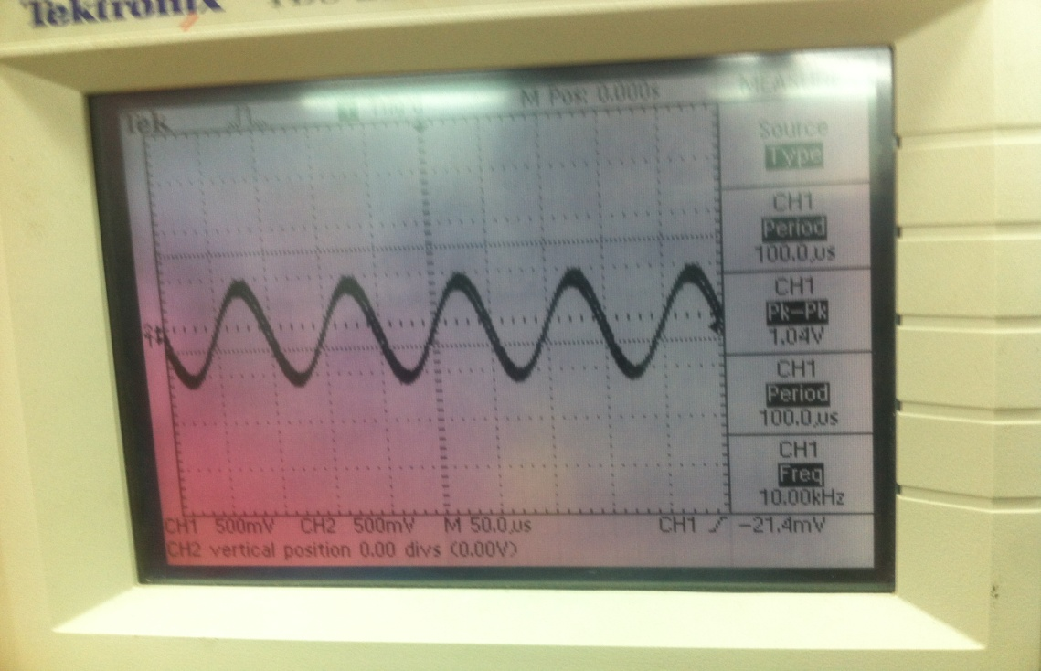f=10KHz

2. Lead Network with Square Wave:
The Theoretical Values of the peak to peak output voltage for a square wave in a lead network are the same as the values for the sinusoidal wave above, since the transfer function is independent of the shape of the signal and depends only on frequency, R and C being constant.

Lead Network with Square Wave Measured Values:
Table11
Frequency | Input Voltage | Output Voltage V_{peak-peak}
100Hz | 1 V_{peak-peak} | 1840 mV_{peak-peak}
1KHz | 1 V_{peak-peak} | 1900 mV_{peak-peak}
10KHz | 1 V_{peak-peak} | 1280 mV_{peak-peak}

Oscilloscope Figures for Lead Network Square Wave:
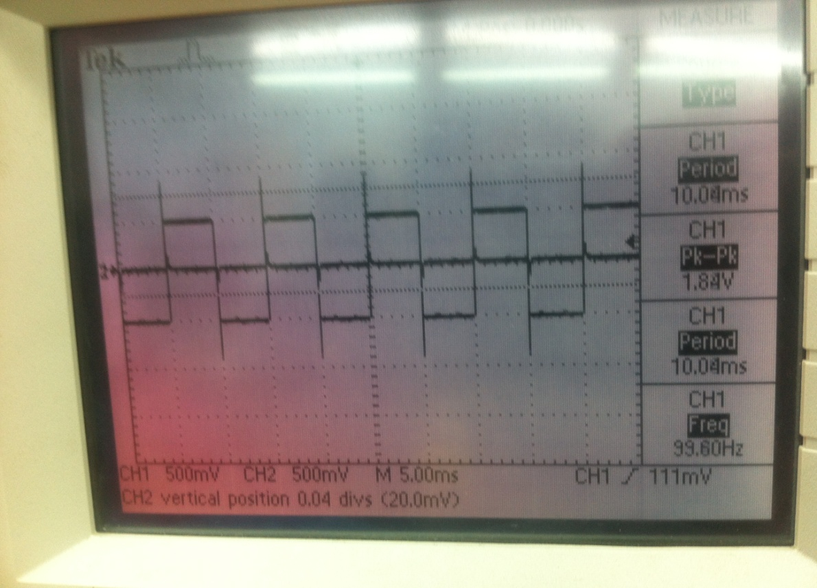f=100Hz

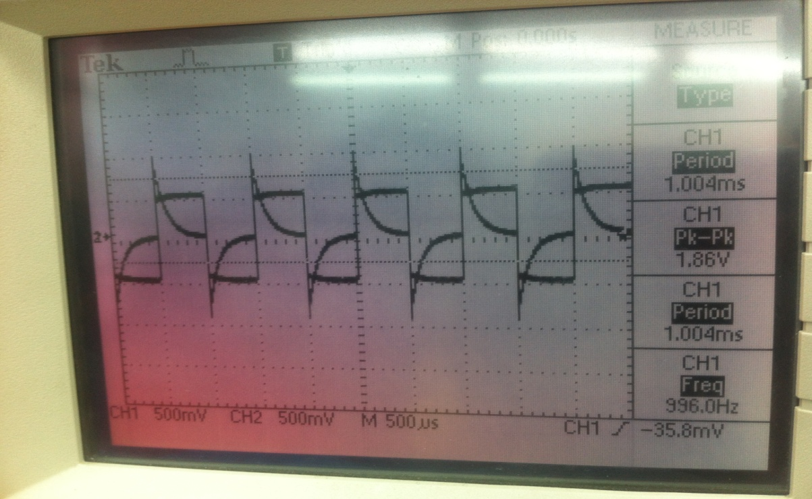f=1KHz

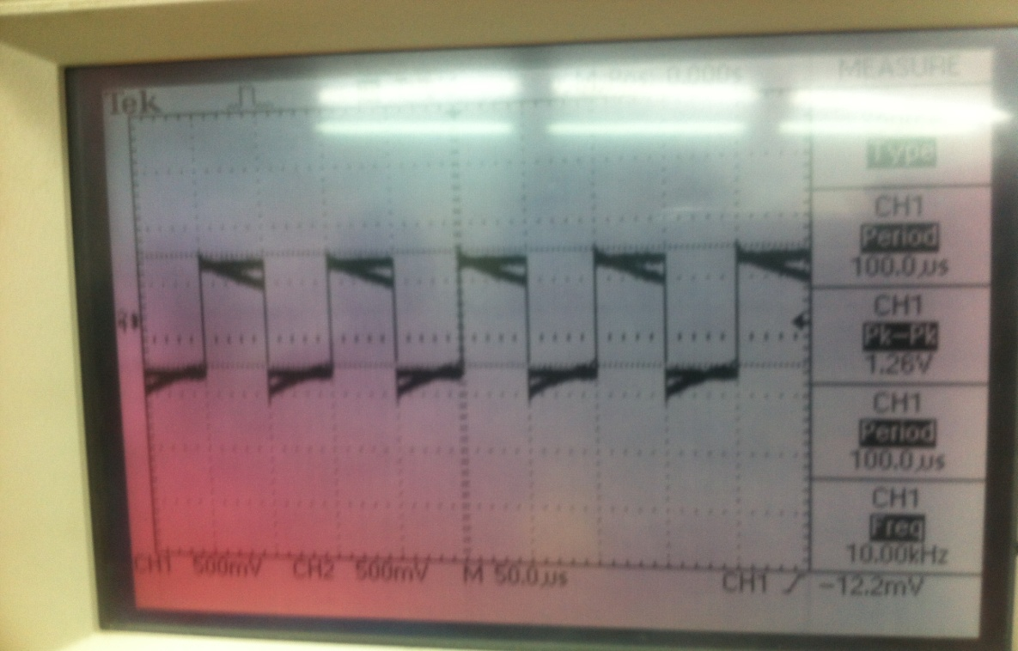f=10KHz

3. Comparison of Lead Sinusoidal and Square Outputs and % Error:
Table12
Frequency | Theoretical Output Voltage | V_{out} for Sinusoidal Input | % Error for Sinusoidal Input | V_{out} for Square Input | % Error for Square Input
100Hz | 62.7mV | 75mV | 19.62 | 1840mV | 2834.6
1KHz | 532mV | 528mV | 0.75 | 1900mV | 257.14
10KHz | 987.5mV | 1020mV | 3.29 | 1280mV | 29.62

Again the sinusoidal output values are closer to the theoretical ones.
B4. Discussions:
-The output voltage of the lag network is equal to the voltage across the capacitor. For low frequencies, the capacitor acts as an open circuit and the output voltage tends to be equal to the input voltage. At high frequencies, it acts as a short circuit and the output voltage tends to zero.
-The output voltage in lead networks is equal to the voltage across the resistor. For low frequencies, the capacitor acts as an open circuit and V_{R} tends to zero. Whereas, at high frequencies, the capacitor acts as a short circuit and the output voltage tends to be equal to the input voltage.
-For square waves, in both lag and lead networks, we observed an output signal that was greater than the input value. This increase in output value can be due to the fact that the capacitor could be in transient state (from charging to discharging), while the voltage would be the same. Also, at lower frequencies, the capacitor has more time to charge fully.
-Another reason for the increased output of square signals is that a lag network acts as an integrator at high frequencies, leading to an output greater than the input. If the 5RC period of charging is longer than the time period of input, the capacitor stays fully charged longer and we get a change in the shape of the signal from square to triangular as seen on the oscilloscope for high frequencies. V_{out}=$\frac{1}{RC}\int_{0}^{t}{Vin dt}$
Lead networks, on the other hand, act as differentiators at low frequencies and the output in this case is the derivative of the input signal. Here, if the 5RC period of the capacitor is shorter than the time of the input, the capacitor gets fully charged before the next cycle and we obtain a change in the shape of the square wave which becomes spiky as the frequency increases. V_{out}=RC$\frac{dVin}{dt}$
-The time constant for RC circuits is equal to RC. And the cutoff frequency is$\frac{1}{RC}$.
Therefore, when f >> 1/RC, the lag network acts as an integrator. i.e. the output voltage V_{c} is the integral of I=C$\frac{dVc}{dt}$. To keep the signal undistorted, the frequency used in lag networks should be less than 1/RC.
The lead network acts as a differentiator when f << 1/RC, since V_{R} = RI = RC$\frac{dVc}{dt}$.
Therefore, for the lead network not to distort the square wave, the frequency should be greater than the cutoff frequency 1/RC.
-According to Fourier expansion for a square wave:
f (t) =$\frac{4Am}{л}$ [cosω_{o}t - $\frac{1}{3}$cos3ω_{o}t + $\frac{1}{5}$cos5ω_{o}t….]
The square wave is the sum of different sinusoidal signals of frequencies ω, 3ω, 5ω…(odd harmonics) and the higher the frequency, the more harmonics will be attenuated with lag networks and the more distortion is obtained. With a similar reasoning, the higher the frequency, the more the harmonics, and the less attenuation or distortion is obtained for lead networks.

-For Sinusoidal Waves:
Sinusoidal waves, unlike square waves are made up of only one frequency. The shape of sine waves is not affected by changes in the frequency, but the amplitude varies with these changes.
The cutoff frequency is defined as the frequency at which the output amplitude is 1/√2 its maximum value. We can get the cutoff frequency by setting the magnitude of the transfer function to 1/√2 and we get ω_{c}=1/RC.
A lag network acts as a low pass filter that attenuates frequencies higher than the cutoff frequency 1/RC, and allows frequencies less than 1/RC to pass.
The lead network acts as a high pass filter that attenuates frequencies less than the cutoff frequency and passes the ones that are higher than 1/RC.
Therefore, what applies to sinusoidal waves can also apply to square waves which are made of a series of many sinusoidal waves or harmonics.

-For lag networks in the s domain: H_{(s)} =$\frac{1}{1+sRC}≈\frac{1}{sRC}$
In Laplace transform:
$ʆ\{\int_{0-}^{t}{f\left(x\right)dx}$} =$\frac{1}{s}$F_{(s)}
meaning that division by s in s domain is equivalent to integration in the time domain. Hence, lag networks act as integrators at high frequencies.
Also, ʆ{$\frac{df(t)}{d(t)}$}=sF_{(s)} –f₍₀₋₎ and for lead networks: H_{(s)}=$\frac{sRC}{1+sRC}≈sRC$, meaning that multiplication in s domain is equivalent to differentiation in time domain. Hence, lead networks act as differentiators at low frequencies.

-If the signal has an average DC value:
From KVL: V_{in}=V_{c}+V_{R}
After t=5RC, V_{c}=V_{in} and V_{R}=0.
When V_{c}=0 after the discharge of the capacitor, V_{in}=V_{R}
Also, since a DC voltage means f=0Hz, we can say that only the lag network can charge the capacitor, since it is a low pass filter circuit. The high pass or lead one won’t let the signal pass.

- Series RLC Circuits
C1. RLC Circuit Diagram:
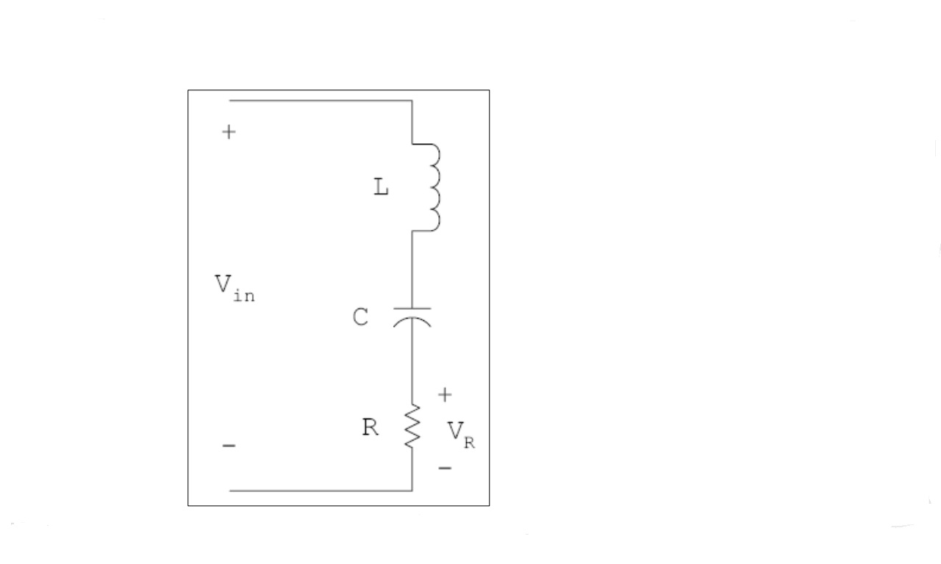Figure 5
C2. Experimental Procedure:
For this part, we connected a resistor to an inductor and a 1μF Capacitor. We supplied the circuit with a 1V peak to peak sinusoidal signal. One channel of the oscilloscope was connected across the resistor (V_{R}) and another was connected across V_{in}.
Two different values of resistors were used: 100Ω and 56Ω .
Two different values of inductors were used: 220μH and 470μH.
We also used a varied range of frequencies.
Assumptions: We assumed that wires have no resistance and disregarded the % error of resistors used.

C3. Calculations, Measurements and Results
1. Theoretical Calculations:
The Resonant Frequency of RLC series circuit is given by: ω_{o} = $\frac{1}{\sqrt{LC}}$ radians/second and
f =$\frac{1}{2л\sqrt{LC}}$ Hz

The Bandwidth is given by: BW= $\frac{R}{L}$ or $\frac{R}{2лL}$ in Hz
Sample Calculation:
R = 100Ω, L = 220μH and C = 1μF
ω_{o} = $\frac{1}{2л\sqrt{(220×{10}^{-6) (}1×}{10}^{-6})}$ = 10730.22 Hz = 10.73KHz

BW = $\frac{100}{2л×220×{10}^{-6}}$ = 72.343KHz

RLC Resonant Frequency and Bandwidth Values:
Table13

Resistance | Inductor | Capacitor | Resonant Frequency | Bandwidth
100Ω | 220μH | 1μF | 10.730KHz | 72.343KHz
56Ω | 220μH | 1μF | 10.73KHz | 40.512KHz
100Ω | 470μH | 1μF | 7.341KHz | 33.862KHz

2.Experimental Results:

Our Results:

R=100Ω, L=220μH, and C=1μF

Table14

Frequency(Hz) | Vin(V) | Vout(V) | ΔT(s) | Output  Lead/lag/in phase  input
5400 | 0.72 | 0.616 | 9μsec | lead
10000 | 0.712 | 0.624 | 2.8 μsec | lag
20000 | 0.760 | 0.632 | 0 | In phase

Sample Calculation for Theoretical Value of the transfer function:
For an RLC circuit: │H(jω)│=│$\frac{V_{R}}{V_{in}}$│= $\frac{R}{\sqrt{{R }^{2}+{(ωL-\frac{1}{ωC})}^{2}}}$
R=100Ω, L=220μH and C=1μF
f=1000Hz ω=2лf=6283.185rad/sec
│$\frac{V_{R}}{V_{in}}$│=$\frac{100}{\sqrt{{100}^{2}+{(6283.185×220×{10}^{-6}-\frac{1}{6283.185×{10}^{-6 }} )}^{2}}}$=0.5353606

Results for the First Table (set 1):

R=100Ω, L=220μH and C=1μF

Table15:

Frequency(Hz) | Vout (V) | Vin (V) | Vout/Vin | ΔT (seconds) | Output vs. input | Theoretical Vout/Vin
1000 | 0.35 | 0.8 | 0.4375 | 0.0014 | leads | 0.5353475
1400 | 0.432 | 0.72 | 0.6 | 0.000092 | leads | 0.6685387
2000 | 0.456 | 0.656 | 0.695122 | 0.000048 | leads | 0.7930462
2800 | 0.504 | 0.664 | 0.759036 | 0.000028 | leads | 0.8836795
4000 | 0.424 | 0.52 | 0.815385 | 0.000013 | leads | 0.9460219
5400 | 0.488 | 0.504 | 0.968254 | 0.000005 | leads | 0.9766266
7500 | 0.472 | 0.504 | 0.936508 | 0.000002 | leads | 0.9941617
10000 | 0.55 | 0.584 | 0.890411 | 0 | In phase | 0.9997811
14000 | 0.552 | 0.608 | 0.907895 | 0 | In phase | 0.9968279
20000 | 0.52 | 0.576 | 0.902778 | 0.0000011 | lags | 0.9811644
28000 | 0.488 | 0.584 | 0.835616 | 0.0000015 | lags | 0.9495712
40000 | 0.48 | 0.592 | 0.810811 | 0.0000017 | lags | 0.8897051
54000 | 0.48 | 0.616 | 0.779221 | 0.0000015 | lags | 0.8127007
75000 | 0.48 | 0.696 | 0.689655 | 0.00000168 | lags | 0.7016464
100000 | 0.432 | 0.752 | 0.574468 | 0.00000148 | lags | 0.5905892
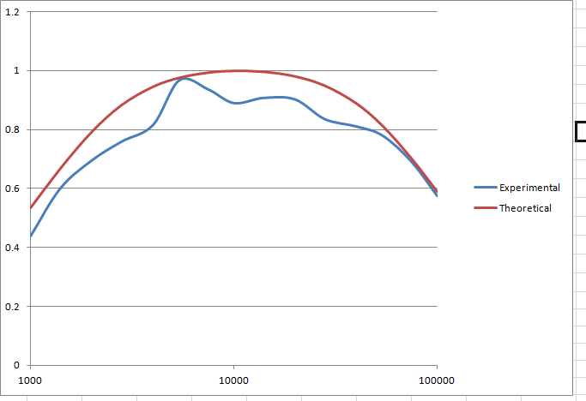
Plot for Set 1

Experimental Measures for set 1:

f1=2115 Hz
f2=71100Hz
BW= 71100-2115= 68985Hz=68.985KHz
Resonant Frequency=5400 Hz = 5.4 KHz

Results for the Second Table (set2):

R=100Ω, L=470μH and C=1μF

Table16:

Frequency(Hz) | Vout (V) | Vin (V) | Vout/Vin | ΔT (seconds) | Output vs. input | Theoretical Vout/Vin
1000 | 0.368 | 0.82 | 0.44878 | 0.000172 | R leads | 0.5391716
1400 | 0.416 | 0.72 | 0.577778 | 0.00009 | R leads | 0.6741889
2000 | 0.44 | 0.656 | 0.670732 | 0.00004 | R leads | 0.8051056
2800 | 0.456 | 0.64 | 0.7125 | 0.000024 | R leads | 0.8995048
4000 | 0.472 | 0.6 | 0.786667 | 0.000012 | R leads | 0.9630231
5400 | 0.488 | 0.6 | 0.813333 | 0.000005 | R leads | 0.9909754
7500 | 0.496 | 0.584 | 0.849315 | 0.000003 | R leads | 0.9999569
10000 | 0.482 | 0.584 | 0.808219 | 0 | In phase | 0.9908578
14000 | 0.48 | 0.6 | 0.8 | 0.000002 | R lags | 0.9578918
20000 | 0.488 | 0.644 | 0.757764 | 0.0000024 | R lags | 0.8904596
28000 | 0.472 | 0.664 | 0.710843 | 0.0000032 | R lags | 0.7923193
40000 | 0.472 | 0.736 | 0.641304 | 0.0000028 | R lags | 0.6589639
54000 | 0.416 | 0.776 | 0.536082 | 0.0000029 | R lags | 0.5383937
75000 | 0.368 | 0.856 | 0.429907 | 0.0000024 | R lags | 0.4148024
100000 | 0.312 | 0.904 | 0.345133 | 0.0000021 | R lags | 0.3222951

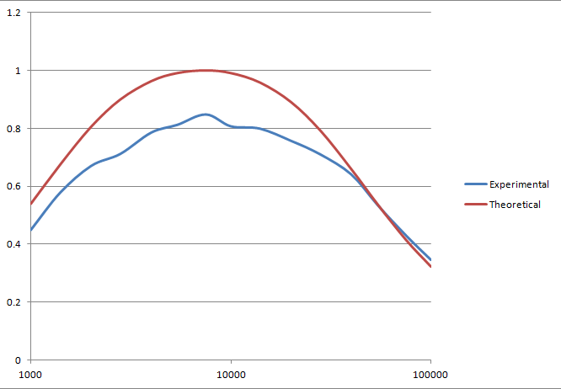
Plot for Set 2

Experimental Measures for set 2:

f1= 2690Hz
f2=28700Hz
BW=28700-2690= 26010Hz=26.01KHz
Resonant frequency=7500 Hz = 7.5 KHz

Results for the Third Table (set 3):

R=56Ω, L=220μH and C=1μF

Table17:

Frequency(Hz) | Vout (V) | Vin (V) | Vout/Vin | ΔT (seconds | Output vs. input | Theoretical Vout/Vin
1000 | 0.24 | 0.8 | 0.3 | 0.000188 | R leads | 0.3344956
1400 | 0.252 | 0.74 | 0.340541 | 0.00011 | R leads | 0.4480234
2000 | 0.296 | 0.592 | 0.5 | 0.000064 | R leads | 0.5891077
2800 | 0.316 | 0.52 | 0.607692 | 0.00004 | R leads | 0.7264837
4000 | 0.332 | 0.48 | 0.691667 | 0.000026 | R leads | 0.8530288
5400 | 0.324 | 0.45 | 0.72 | 0.000011 | R leads | 0.9307022
7500 | 0.344 | 0.432 | 0.796296 | 0.000007 | R leads | 0.9817318
10000 | 0.34 | 0.42 | 0.809524 | 0 | In phase | 0.9993026
14000 | 0.34 | 0.42 | 0.809524 | 0 | In phase | 0.9899891
20000 | 0.336 | 0.432 | 0.777778 | 0.000003 | R lags | 0.9433938
28000 | 0.332 | 0.456 | 0.72807 | 0.0000035 | R lags | 0.8614017
40000 | 0.328 | 0.488 | 0.672131 | 0.0000028 | R lags | 0.7372864
54000 | 0.316 | 0.552 | 0.572464 | 0.0000026 | R lags | 0.6155538
75000 | 0.296 | 0.632 | 0.468354 | 0.000002 | R lags | 0.4828932
100000 | 0.268 | 0.712 | 0.376404 | 0.0000018 | R lags | 0.3792269

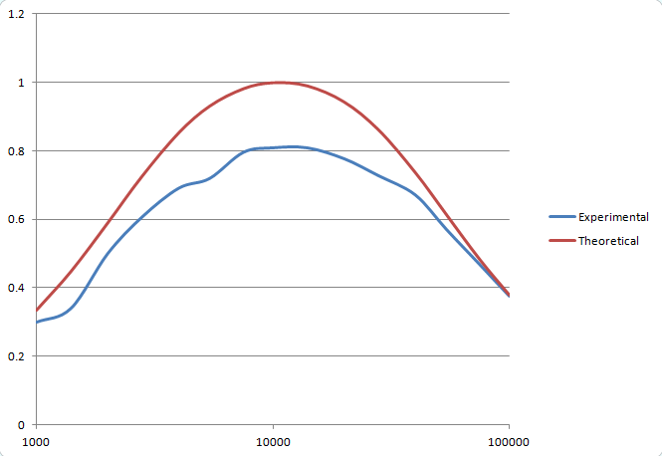
Plot for Set 3

Experimental Measures For set 3:
f1=4700Hz
f2=32450Hz
BW=27750 Hz = 27.75 KHz
Resonance Frequency=10000 Hz = 10 KHz

C4. Discussion

Comparison of Results and % Error:

Resistance | Inductor | Capacitor | Resonant Freq. Theoretical | Resonant Frequency Experimental | Resonant Frequency %Error | BW  Theoretical  (KHz) | BW Exp  (KHz) | BW % Error
100Ω | 220μH | 1μF | 10.73KHZ | 5.4KHz | 49.7 | 72.343 | 68.985 | 4.64
100Ω | 470μH | 1μF | 7.341KHz | 7.5 KHz | 2.17 | 33.862 | 26.01 | 23.2
56Ω | 220μH | 1μF | 10.73KHz | 10 KHz | 6.8 | 40.512 | 27.75 | 31.5

-The experimental values of the resonant frequency and bandwidth differ to various degrees as shown in the table above. This may be due to misreading plots, ignored % errors in resistors, the resistance of the inductor and also resistance in the wires of the circuit.

-BW=R/2лL Hz
Therefore, bandwidth is directly proportional to R. As the resistance increases, the bandwidth increases and the opposite is true. Sets 1 (R=100Ω and BW=72.343 KHz) and 3 (R=56Ω and BW=40.512 KHz) show this clearly.

-BW=R/2лL
Therefore bandwidth is inversely proportional to L. As L increases, bandwidth decreases as in sets 1 (L=220μH and BW=72.343 KHz) and 2 (L=470μH and BW=33.863 KHz).

-BW=R/2лL
Therefore, bandwidth is independent of C.

-Bandwidth=f₂ –f₁ where f₂ and f₁ are the frequencies where the magnitude of the transfer function is 1/√2 times its maximum value. We use this fact to get the bandwidth from the plots.

-Comparison of plots and theoretical values:
For the same values of L and two different values of R (sets 1 and 3), the resonance frequency does not vary, since f =1/2л√LC.
The experimental value of resonance for set 1 is 5.4 KHz and is far from the theoretical one which is 10.73 KHz. For set 3 it is 10 KHz which is close to the theoretical value 10.73 KHz.
For different values of L, and the same value of R (sets 1 and 2), the resonance frequency decreases as L increases, since it is inversely proportional to √L.
The experimental value of resonance frequency for set 1 is 5.4 KHz and is far from the theoretical one which is 10.73 KHz. For set 2 it is 7.5 KHz which is close to the theoretical value 7.341 KHz.

- References:
Sabah N.(2008), Electric Circuits And Signals, Taylor and Francis Group, CRC press.
Nilsson& Riedel (2011), Electric Circuits,Pearson, 9th Edition.
www.electronics-tutorials.ws/rc/rc_3.html

- Mistakes and Problems:
The biggest problem we faced was reading the oscilloscope values. The screen values kept changing and sometimes we had to estimate the best average value.
Another problem was noise in the oscilloscope.

